**Exp 4. Using Git Repositories and FTP Tools for Remote File Storage and Access (Duration: 3 Sessions × 2 Hours Each)**

1. **Install Git on the Ubuntu VM**

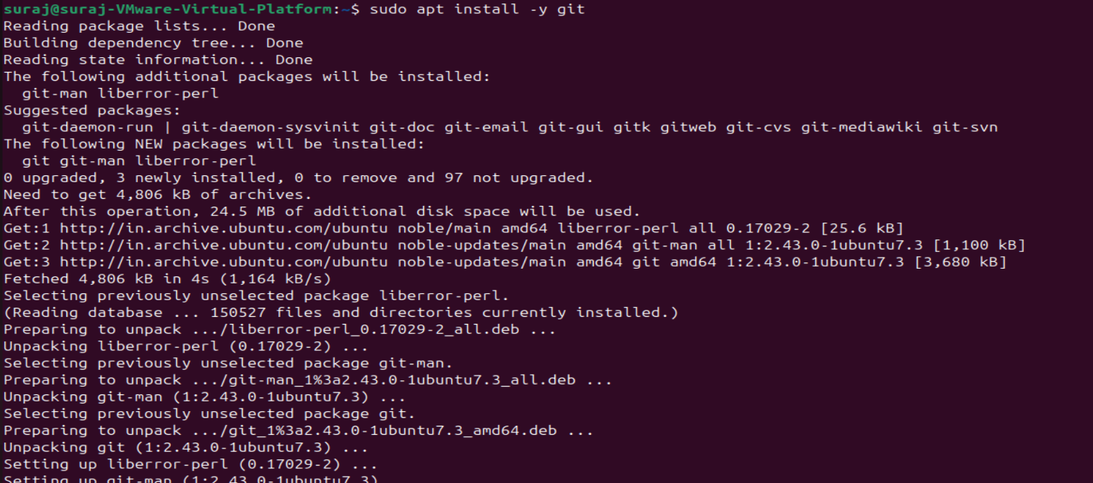

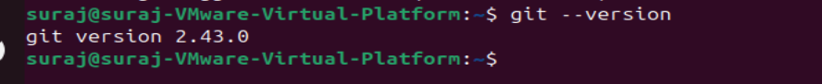

1. **Install and enable SSH server on the VM**



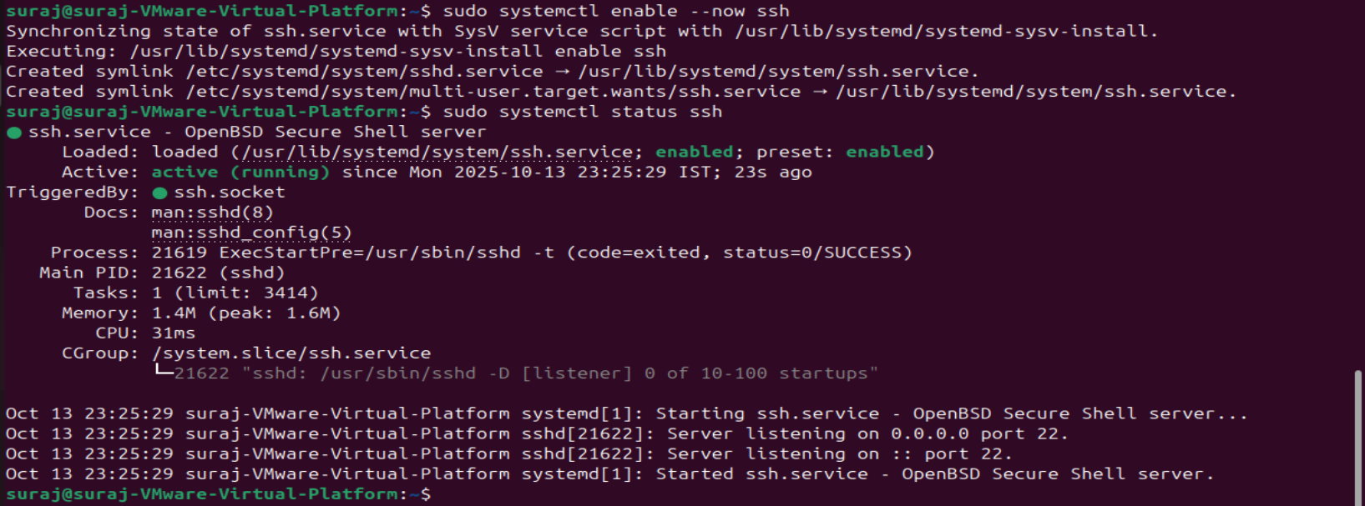

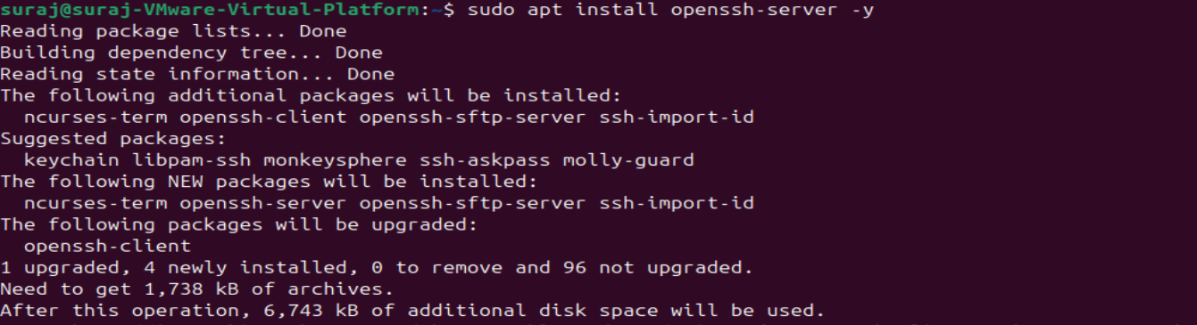

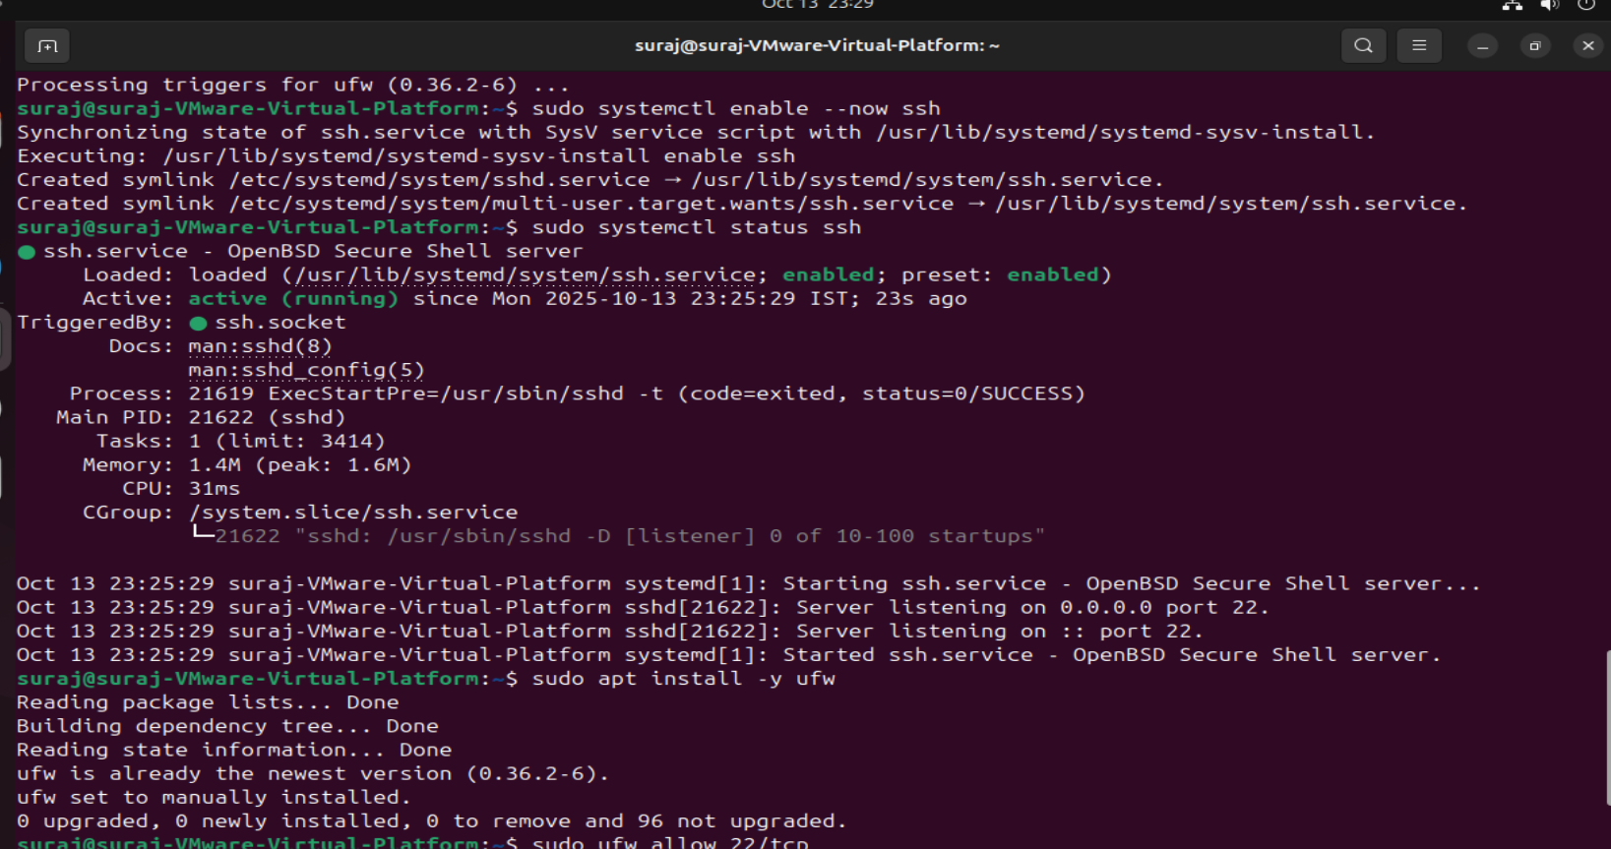

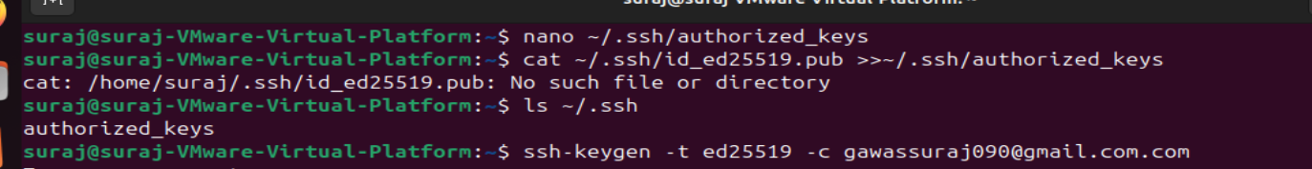

**FileZilla (or WinSCP/cuteFTP) installed.**

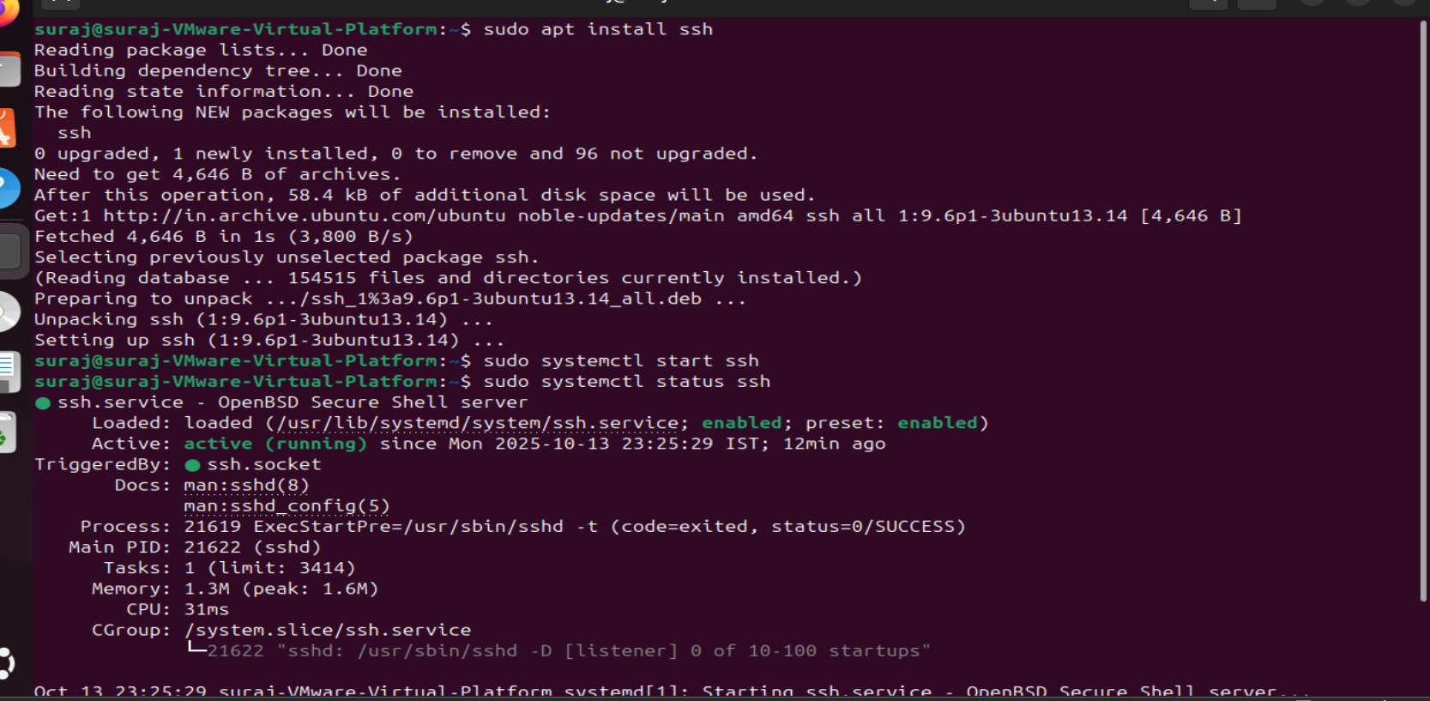

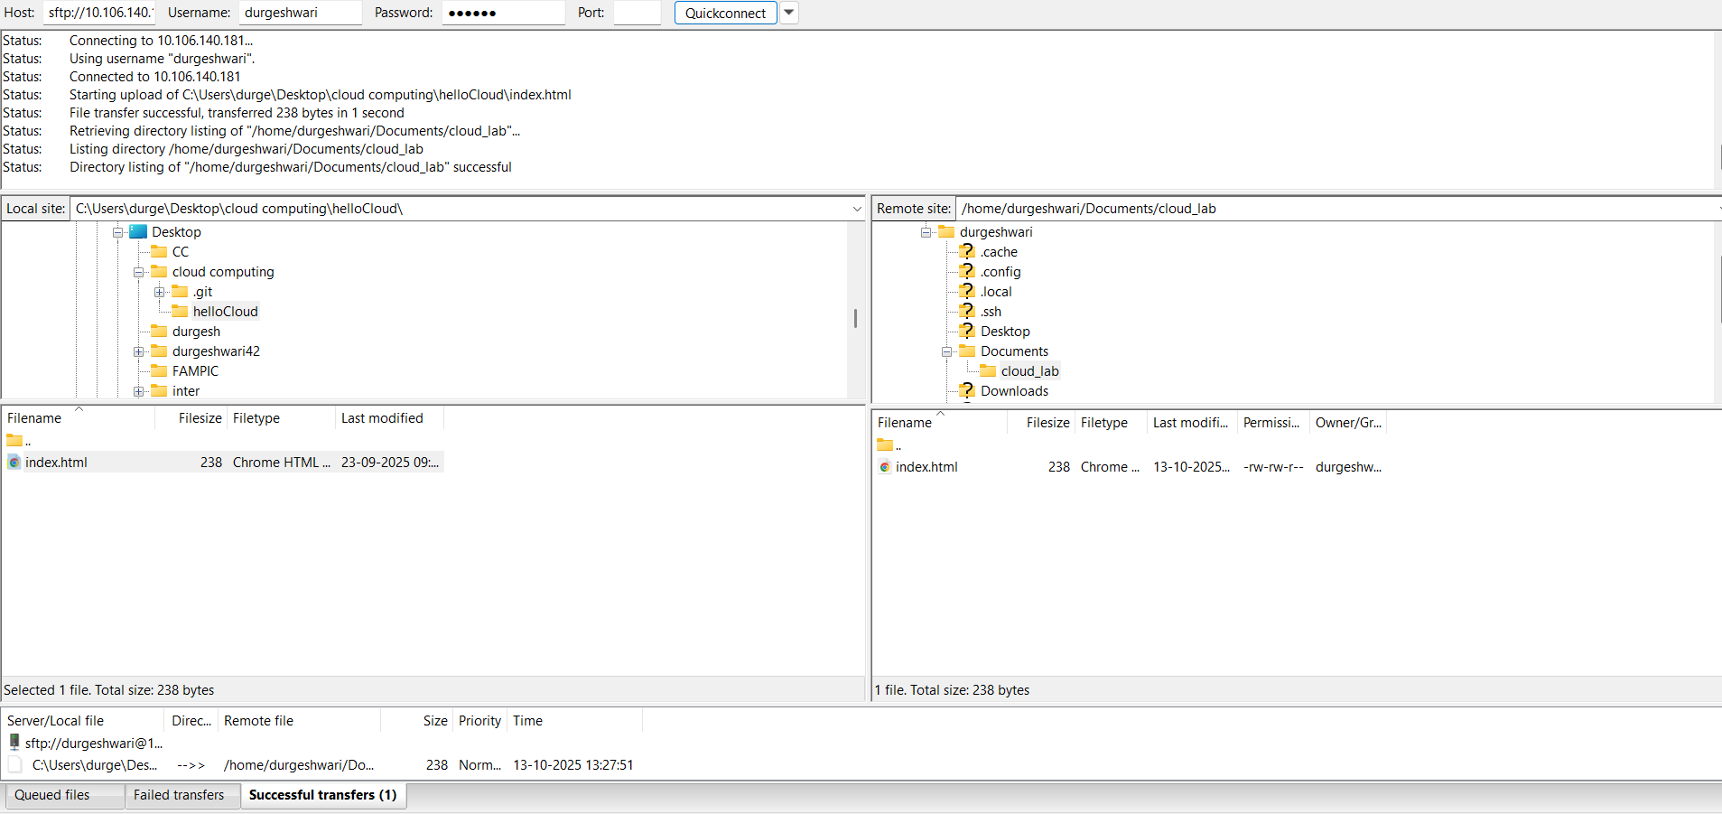

**Session 1 (2 hours): Upload files via FTP/SFTP and initialize Git repo on VM**

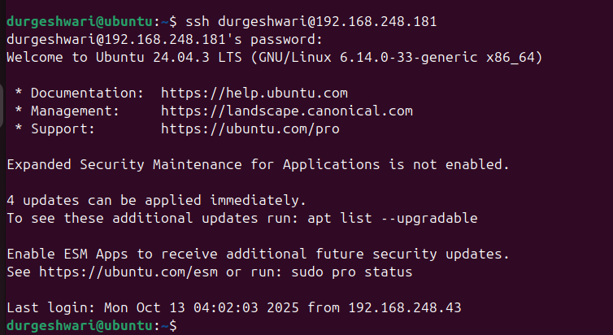

**Session 1: Static Website + GitHub + Deployment via Vercel/Render**

1. **HTML Page Creation**

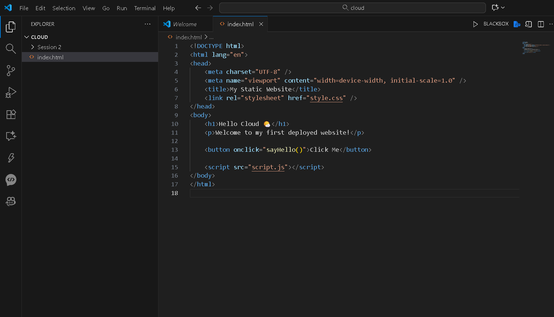

1. **GitHub Setup & Code Push**

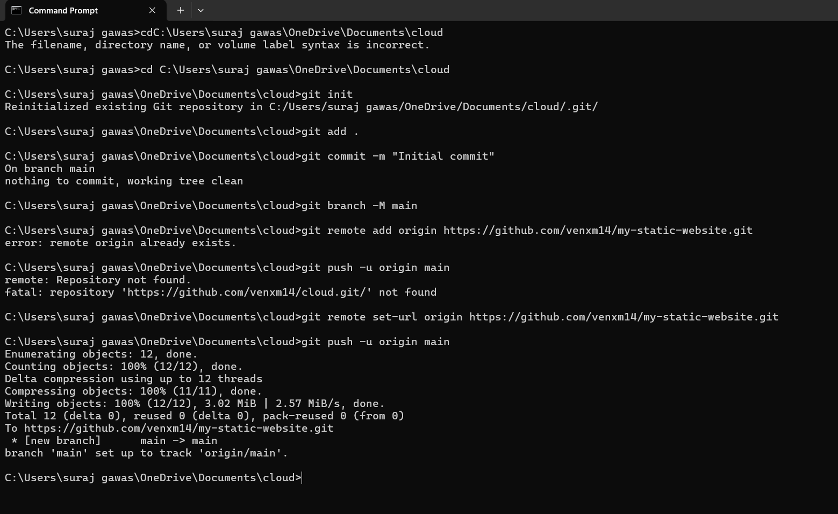

1. **Deploy with Vercel OR Render**

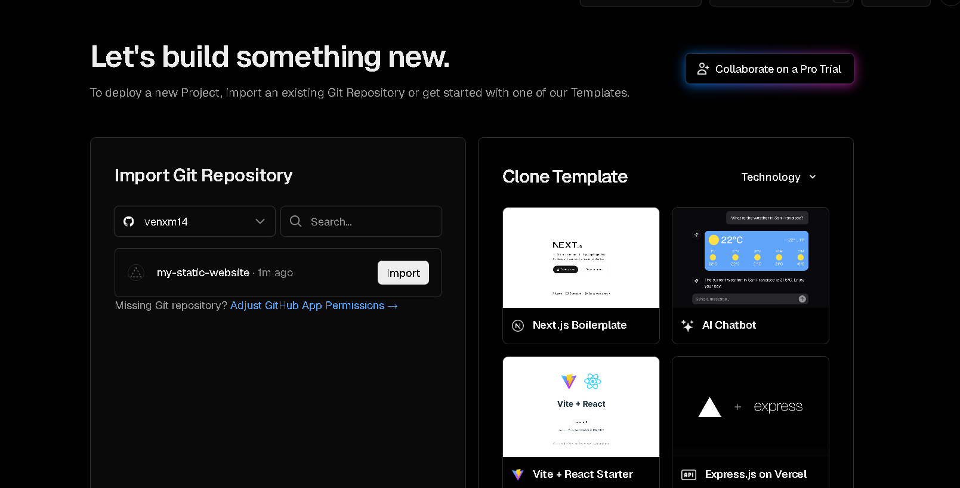

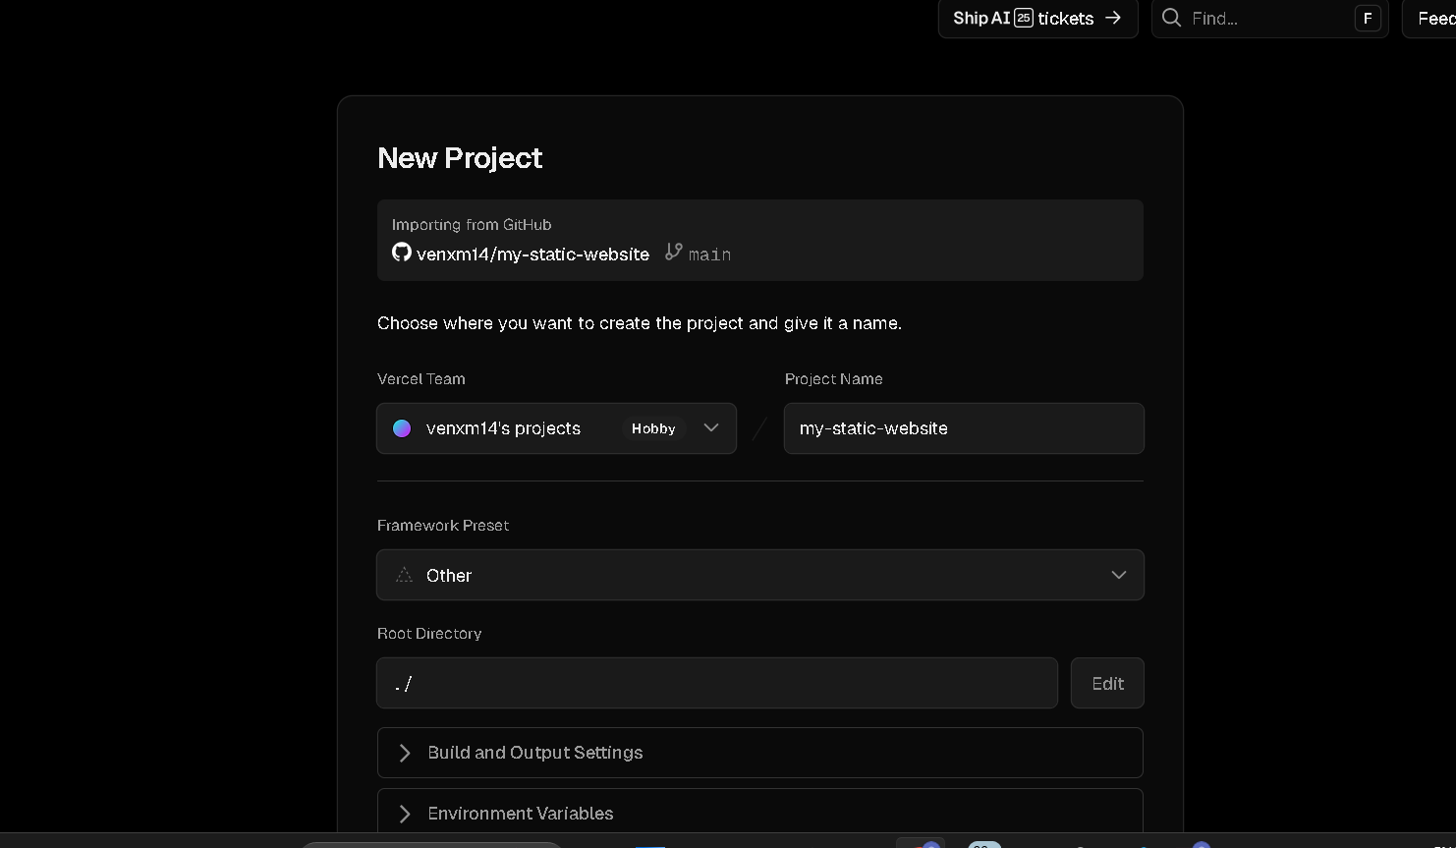

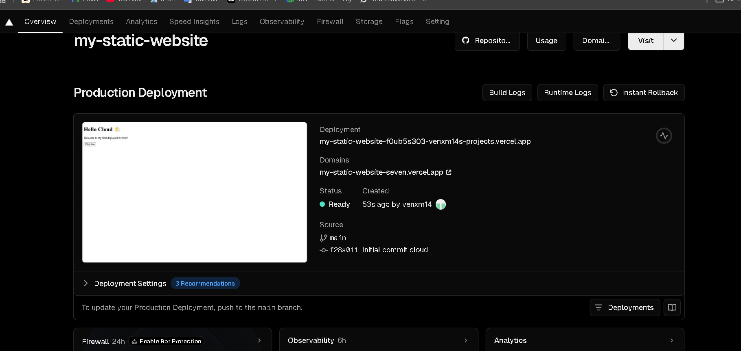

**Session 2: VirtualBox VM + MySQL Installation + Linux Terminal Practice**

1. **Launch Pre-configured Ubuntu/Kali VM**
2. **Basic Linux Commands Practice**

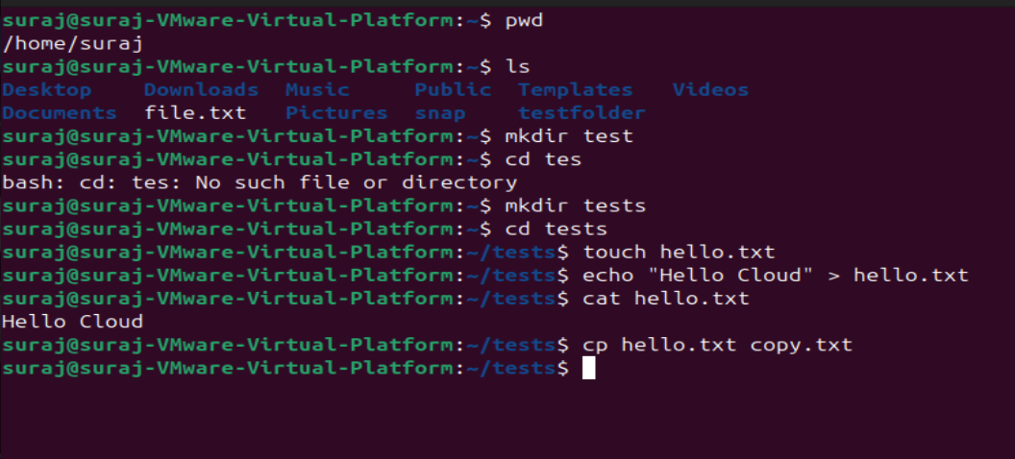

1. **Install MySQL Server**

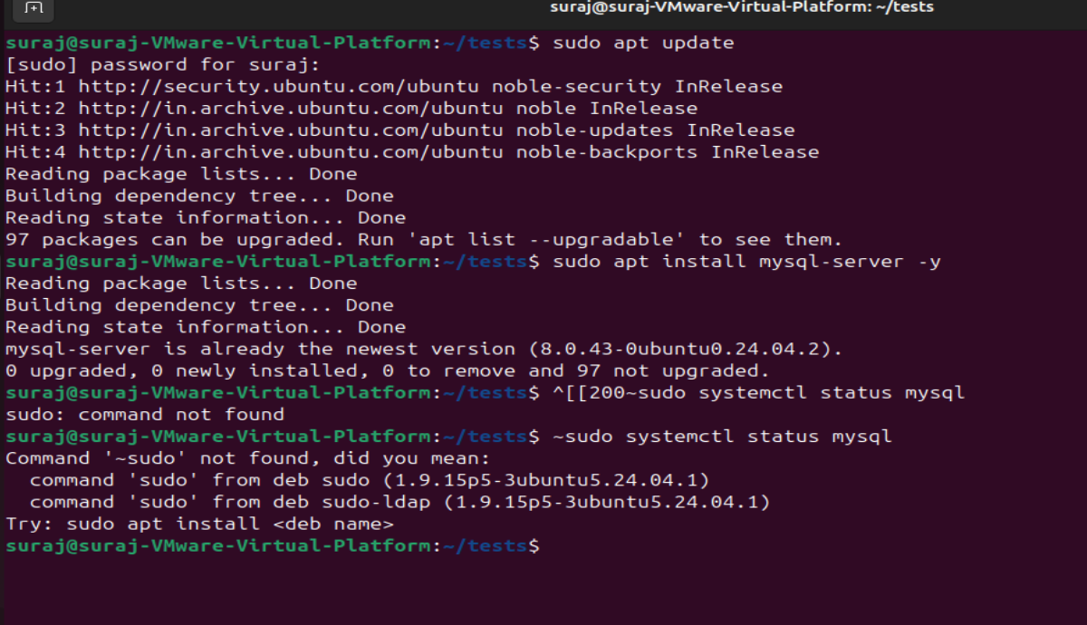

1. **Login to MySQL & Create Table**

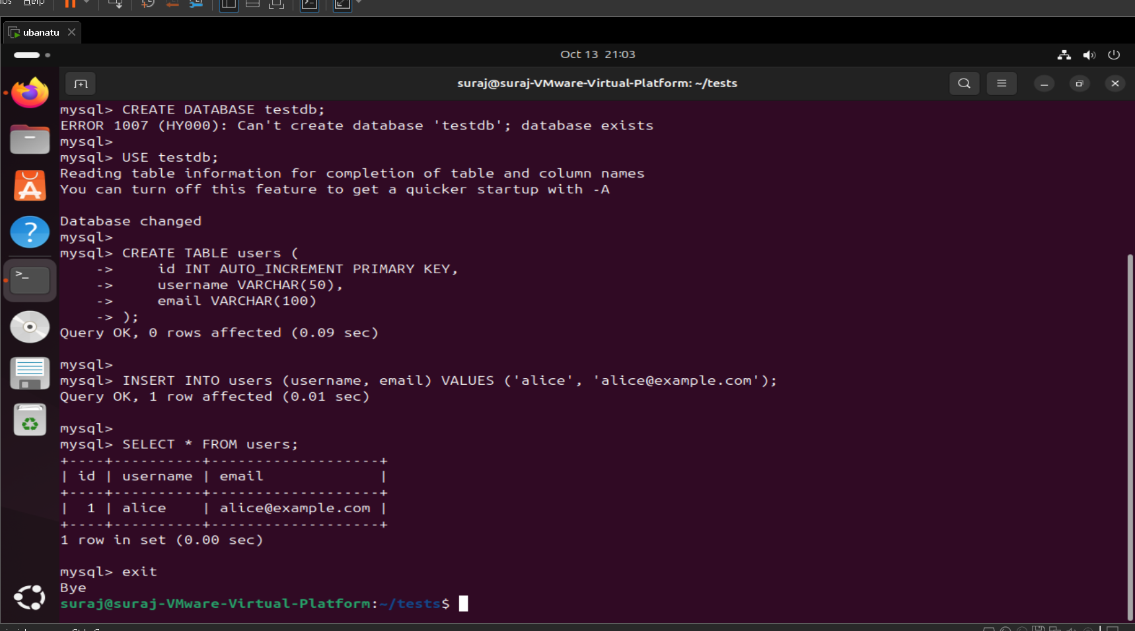

1. **Enable MySQL to Accept Remote Connections**

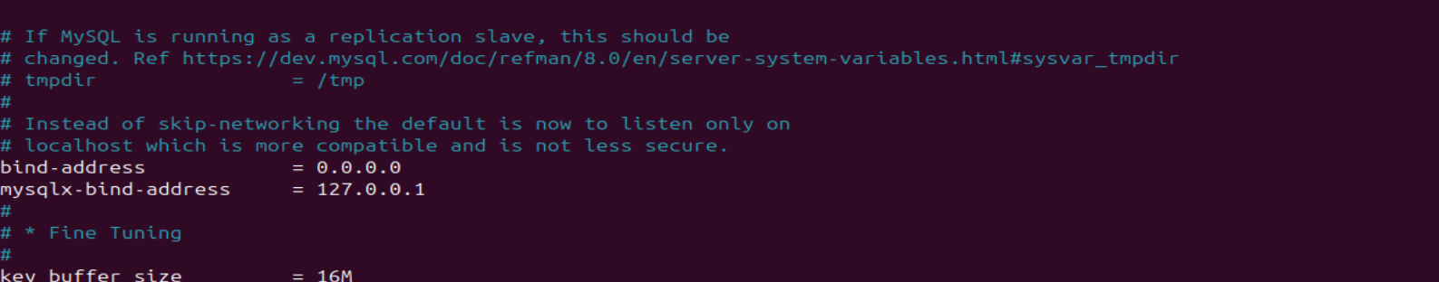

1. **Create Remote User**

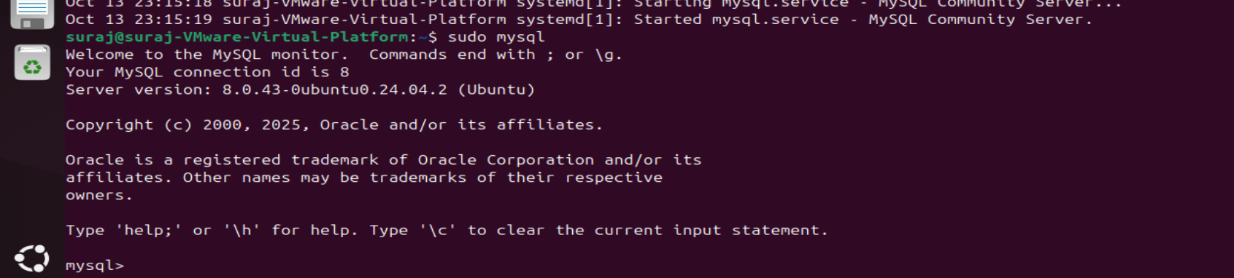

**Session 3: Remote DB Access via Workbench/HeidiSQL + Recap**

**Activities:**

1. **Configure VM Network**

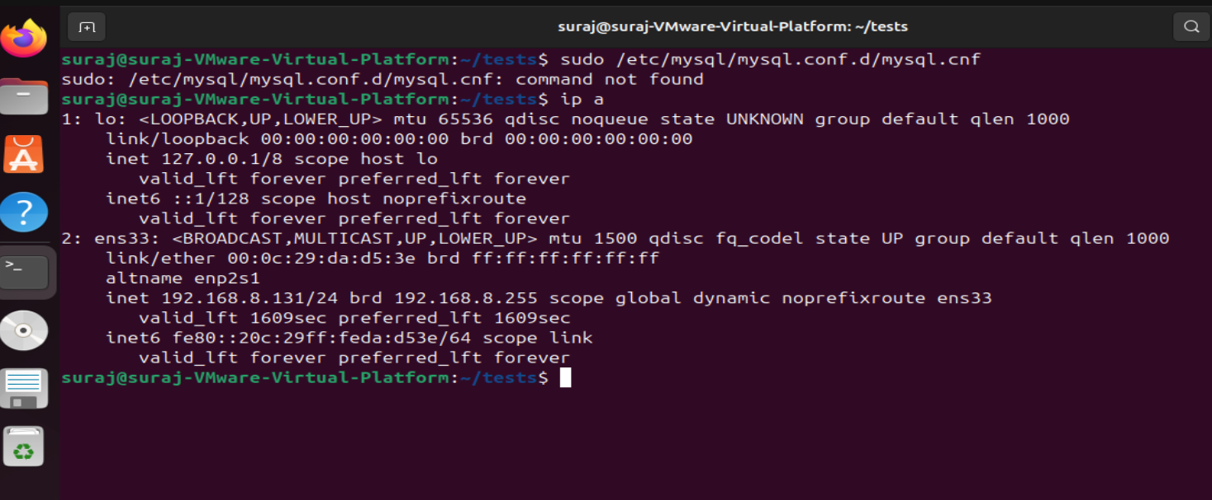

1. **Launch MySQL Workbench / HeidiSQL on Host**

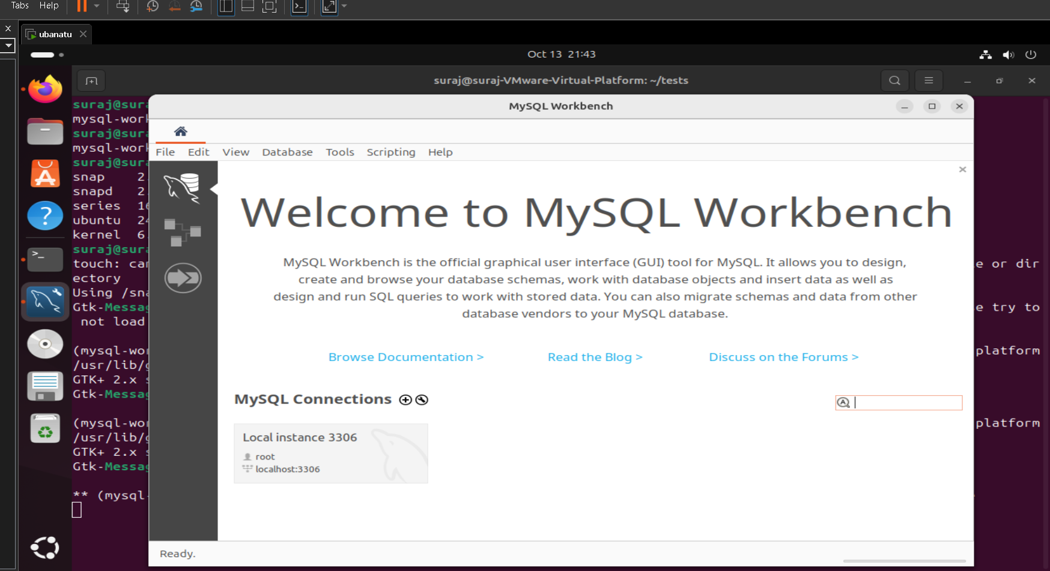

1. **Test Connection & Query**

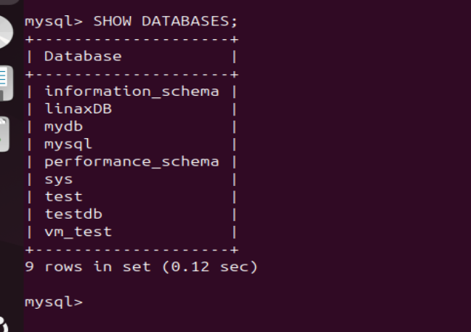

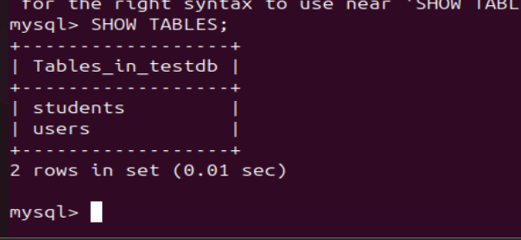

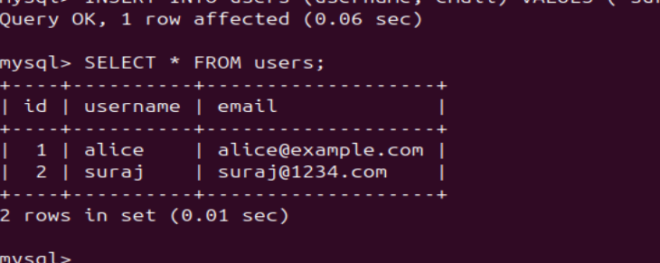

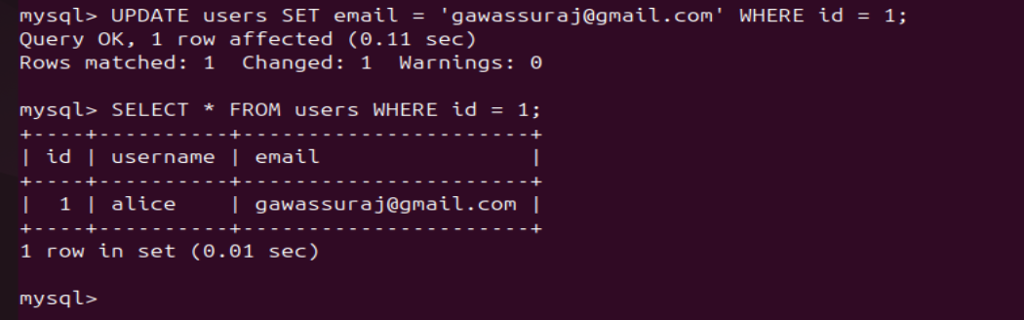

**5. Event Scheduling and Meet Setup using Calendar**

**1. Access Google Calendar**

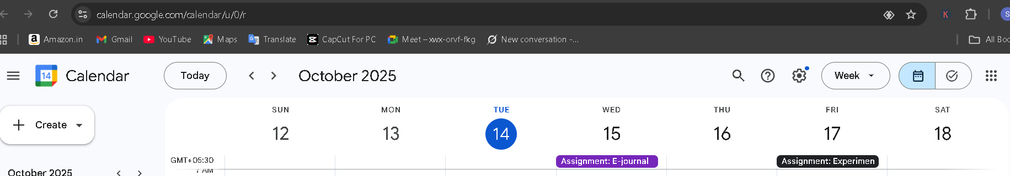

**2. Create a New Event**

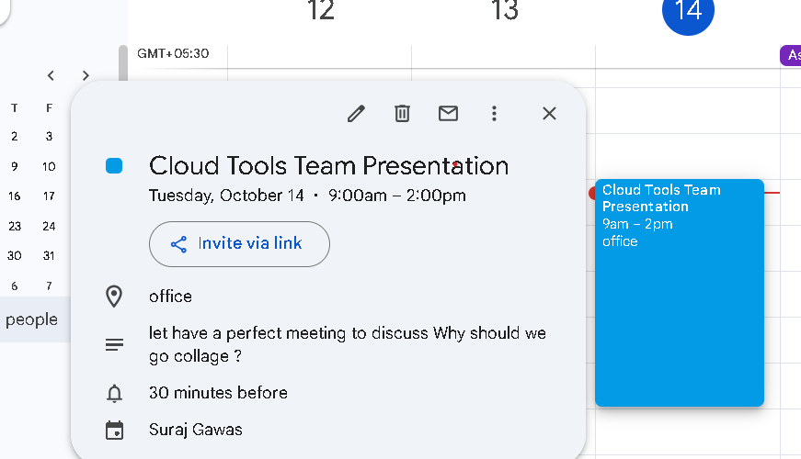

**3. Add Participants**

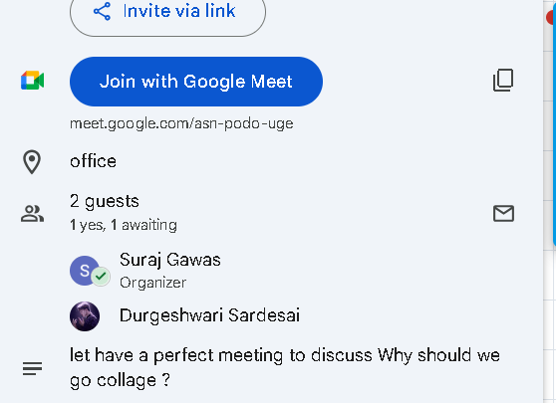

**4. Enable Online Meeting Link**



**5:Add Description and Agenda**

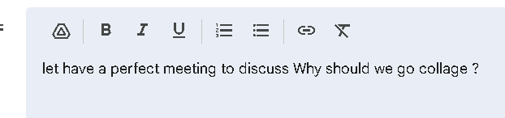

**6. Set Reminders**



**7. Confirmation and Sharing**

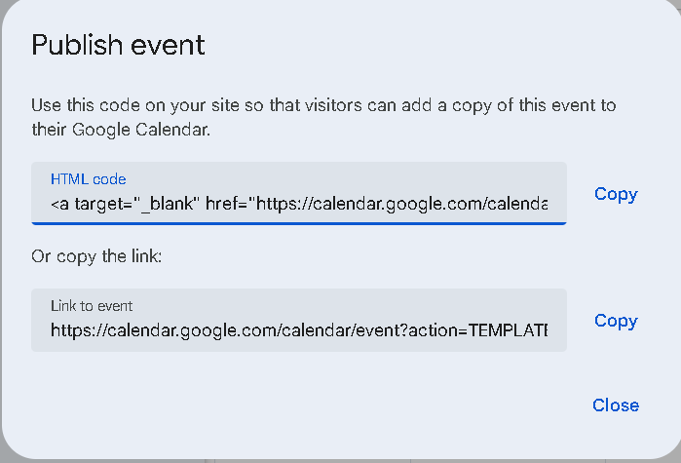

1. **Presentation Collaboration using Slides**

**1:Group Formation and role assignment**

|  |  |  |
| --- | --- | --- |
| **Student Name** | **Role** | **Responsibility** |
| **Elaine** | **Presenter** | **She should present our work to everyone** |
| **janvhi** | **Slide Designer** | **She should design slide** |
| **Anish** | **Content writer** | **Writer content on given topic** |

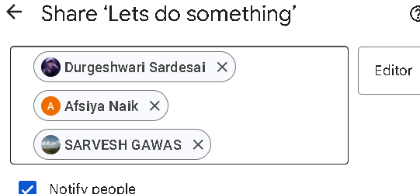

**Create and Share the Presentation**

**Create and Share the Slide Deck:**

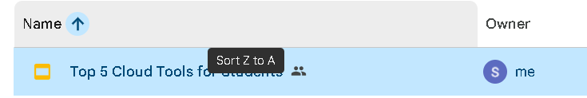

1. **Structure of the Presentation:**

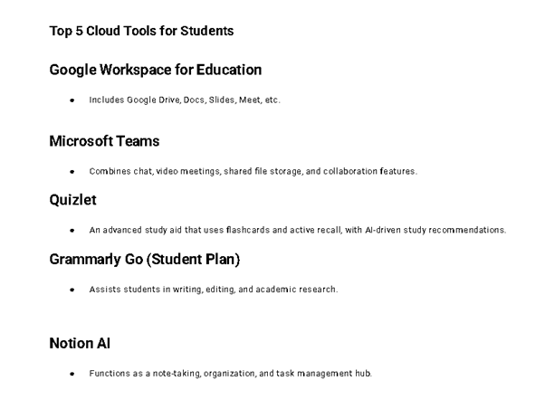

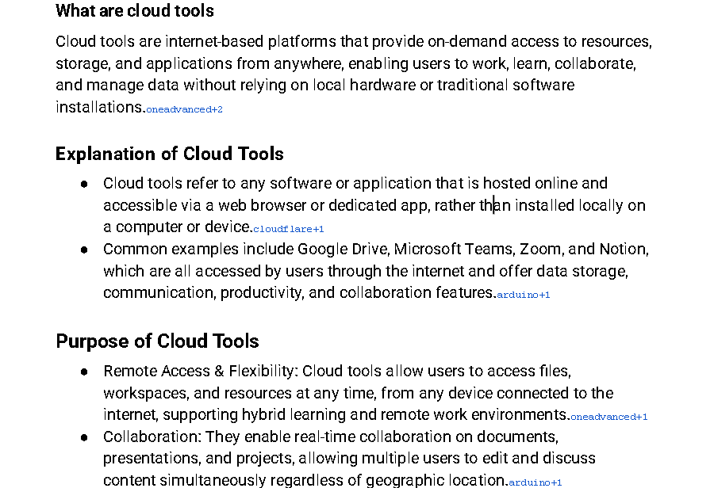

**4: Apply Collaborative Features**

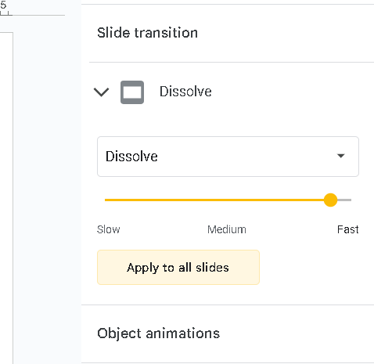

* **Speaker notes** for presentation cues.

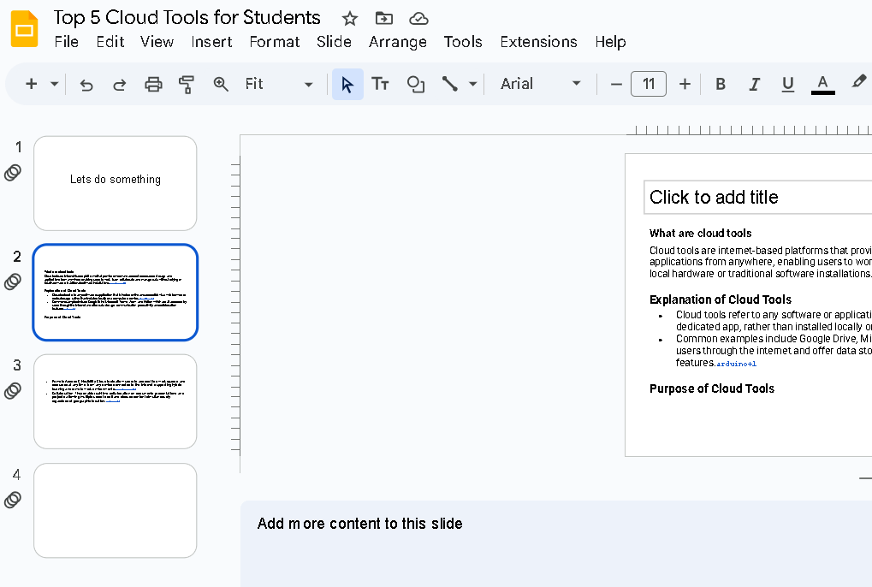

**Charts or tables**

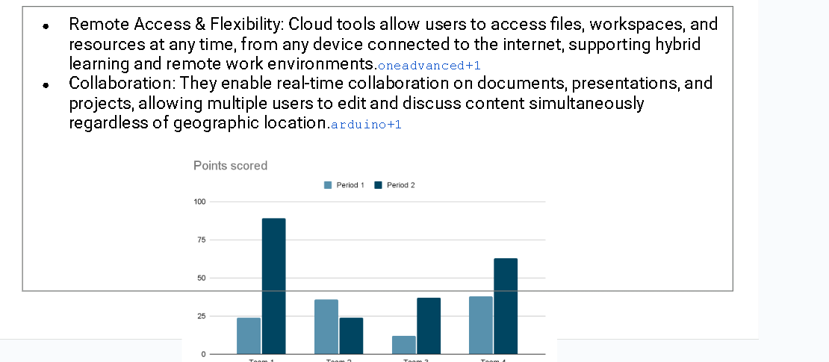

**Images or icons**

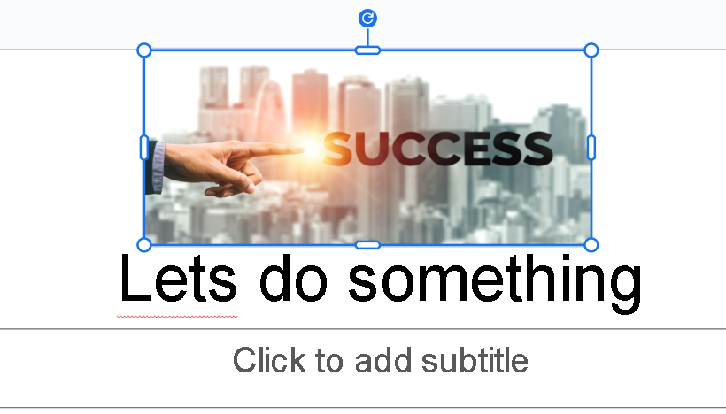

**Comments**

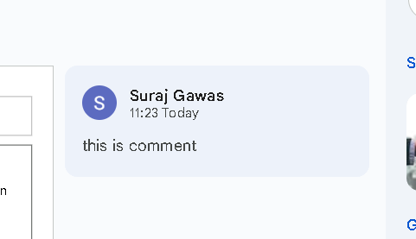

**Survey and Quiz Design using Forms**

**1.Create the Survey Form**

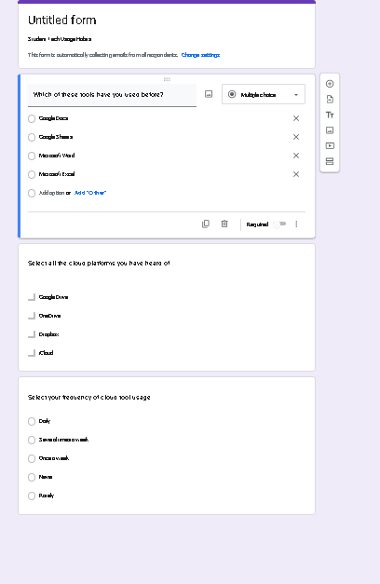

**2.Customize and Share Survey**

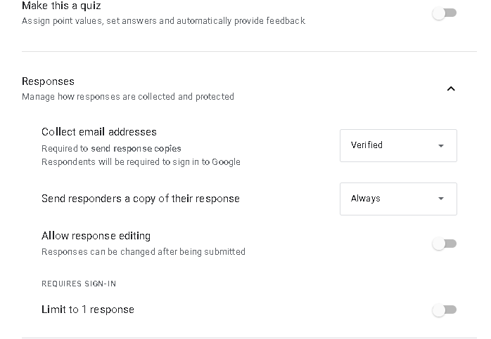

1. **Create a Second Form – Quiz**

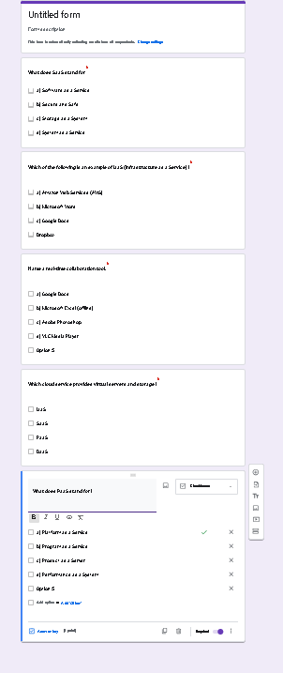

**6.Review Collected Data (Optional)**

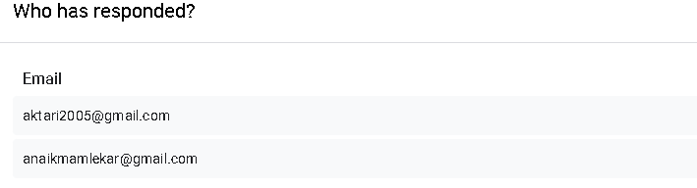

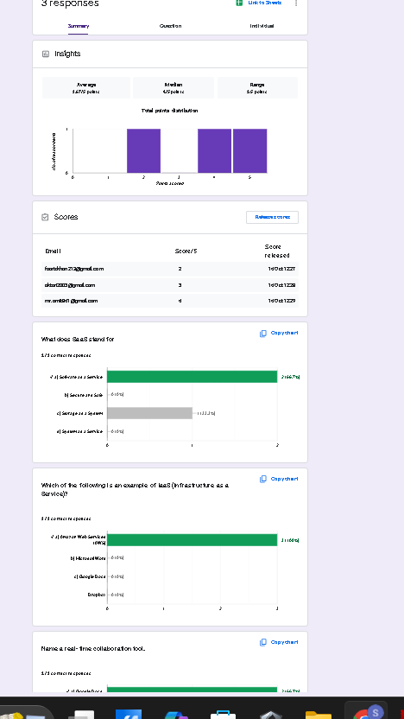

**8. Simulated Virtual Meeting and Chat Collaboration**

**1. Pre-Meeting Setup**

|  |  |
| --- | --- |
| **Students** | **Roles** |
| **Suraj** | **Moderator** |
| **Amit** | **Presenter** |
| **Akshat** | **Note-taker** |

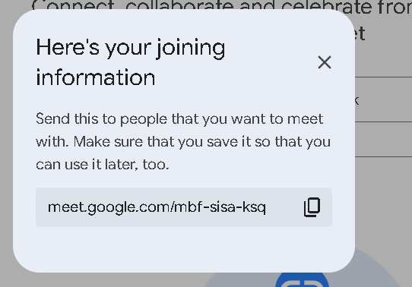

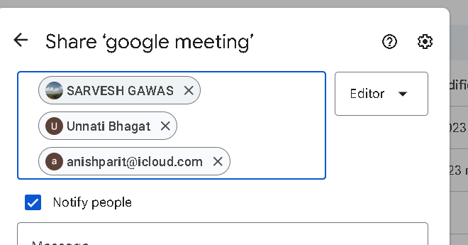

Exp 1 :

1. Get login info from terminal



1. Start a ftp server on ubuntu

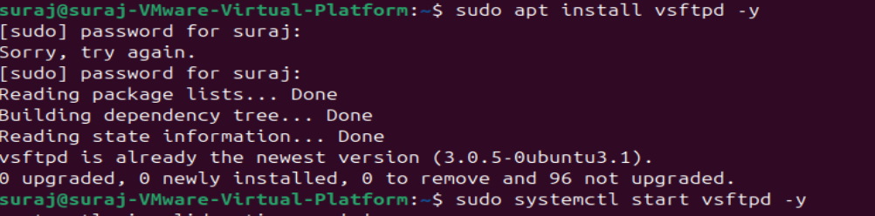



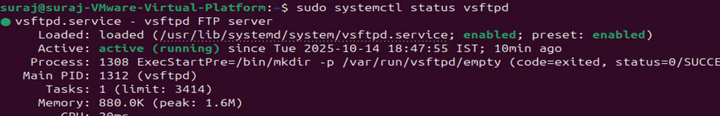

Make sure its saying running and says active



1. Open install filezilla on windows and enter ubuntu login info and select your files to send

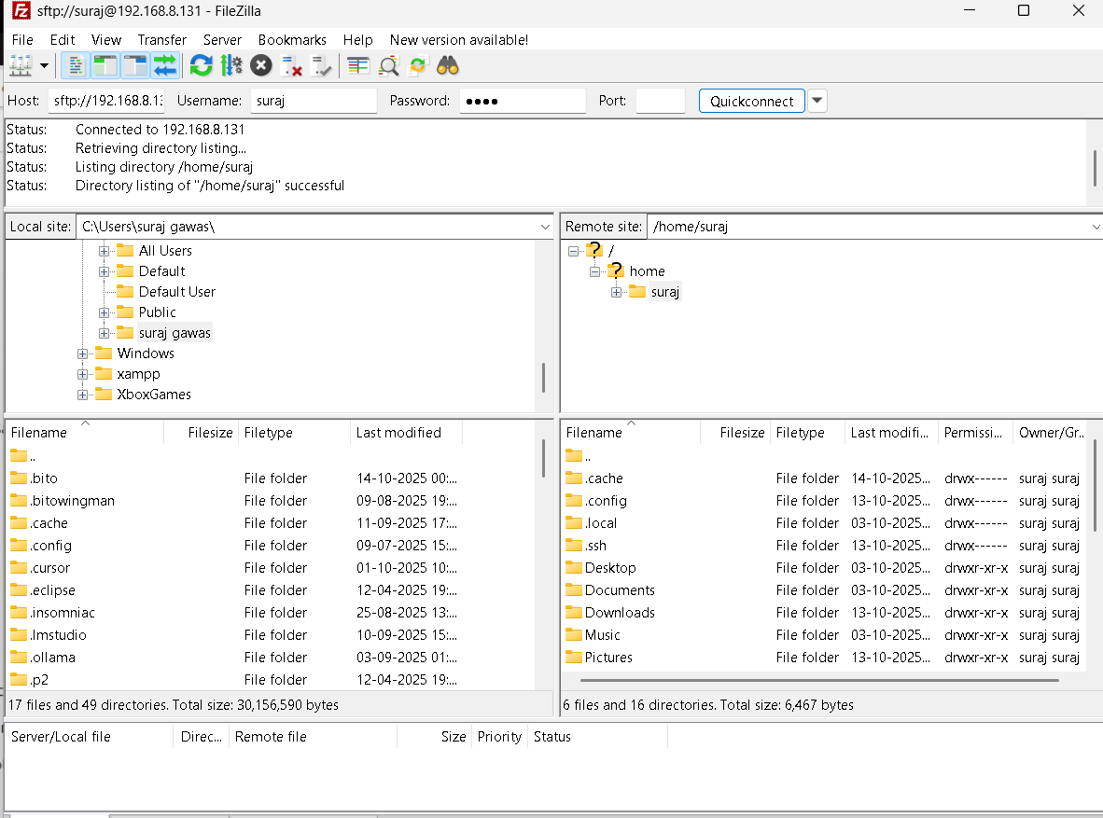

1. Click on transfers then process all transfers or ctrl + P

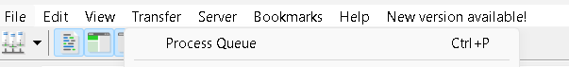

1. Wait for all files to be successful

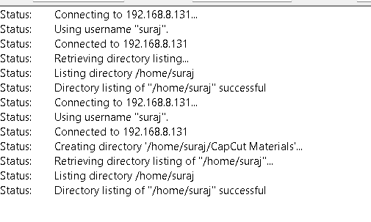

1. Open folder (files received ) terminal and enter these commands

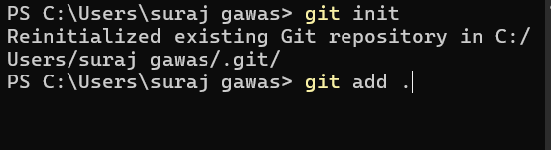



1. Create a new repo in github

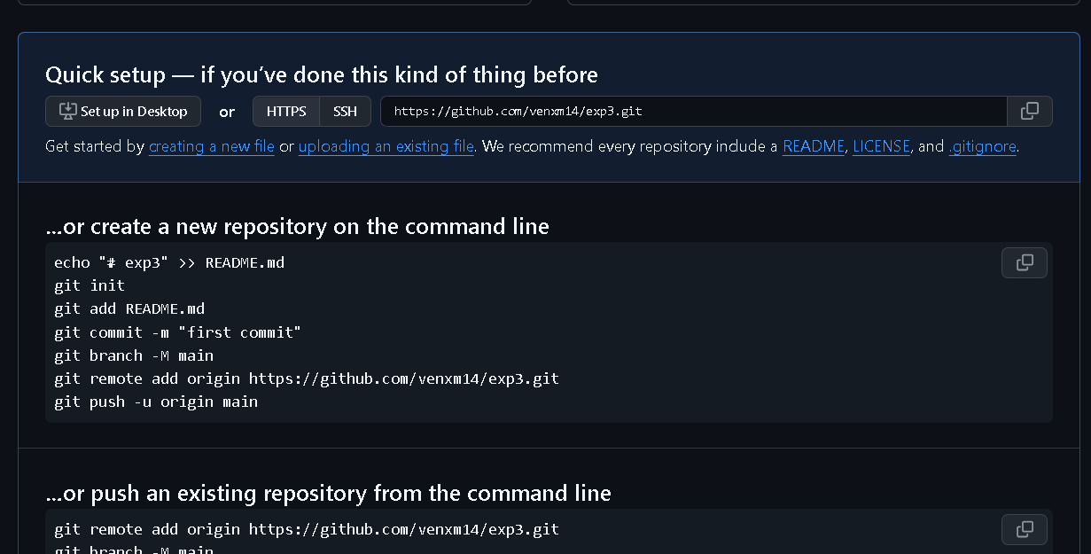

1. Now put these commands to add files to this repo







Exp 2:

1. Clone the repo with this command



1. Make a change in host pc and commit

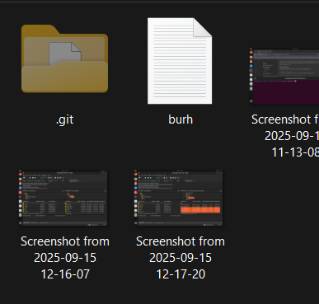

1. And update the vmware repo with these command









1. Add any file and commit





1. Now update the host



1. Make sure your ftp or sftp server is running

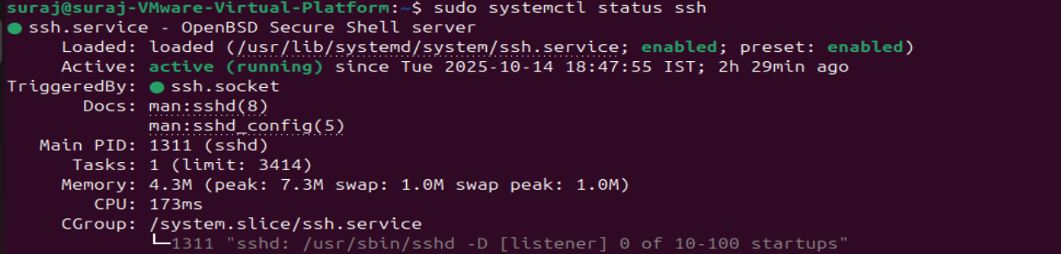

1. To validate using filezilla do these steps

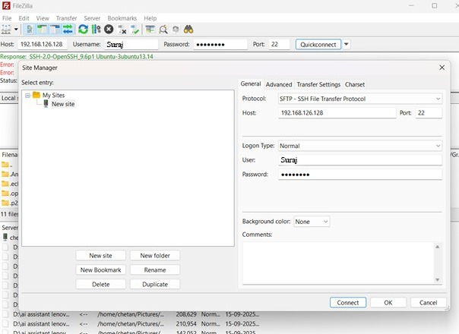

suraj

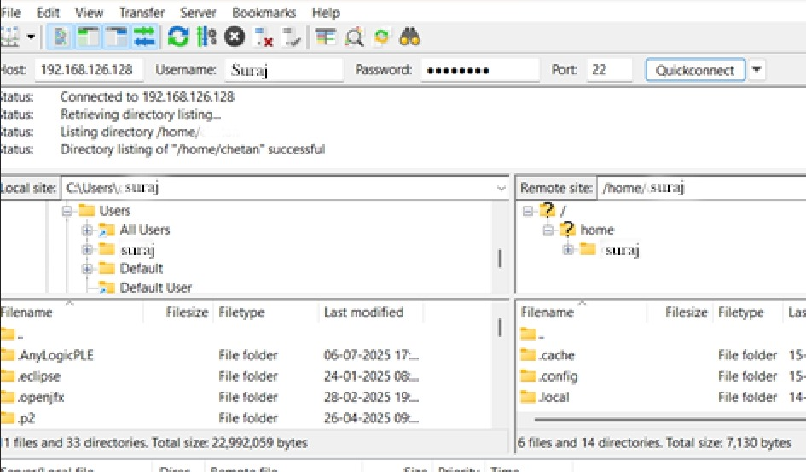

|  |
| --- |
|  |
| Suraj\ |  |

1. compare if both git folders are the same (if not they are not in sync)

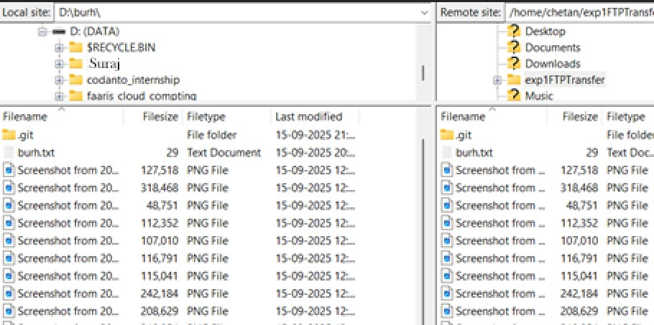

Exp 3:

1. Make your friend a collabator in github

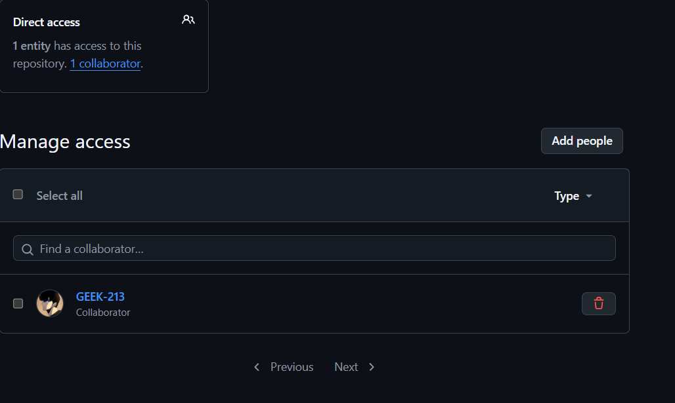

1. Make your friend clone the repo and make some changes

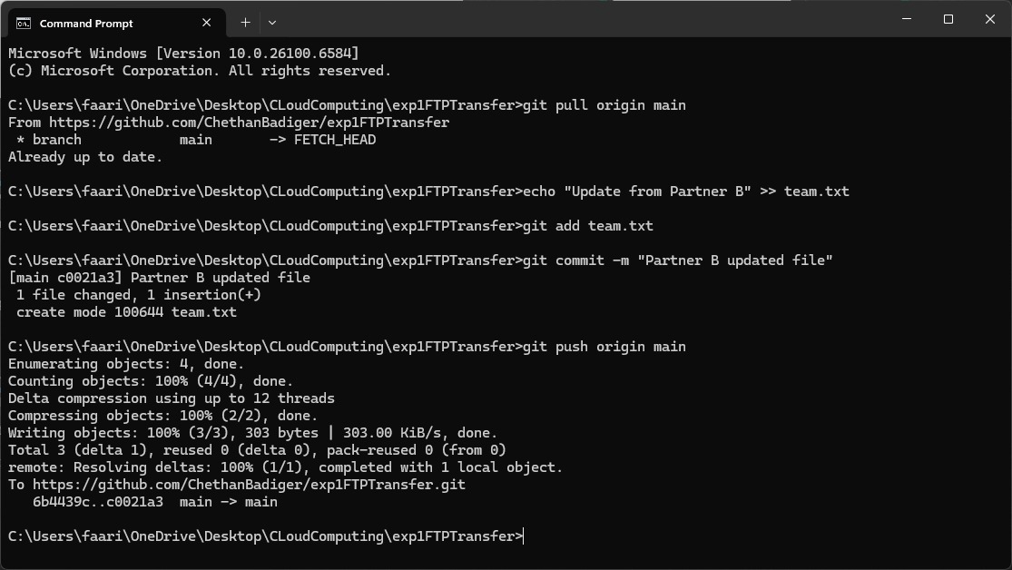

Check on github



1. Now you git pull and you make some changes

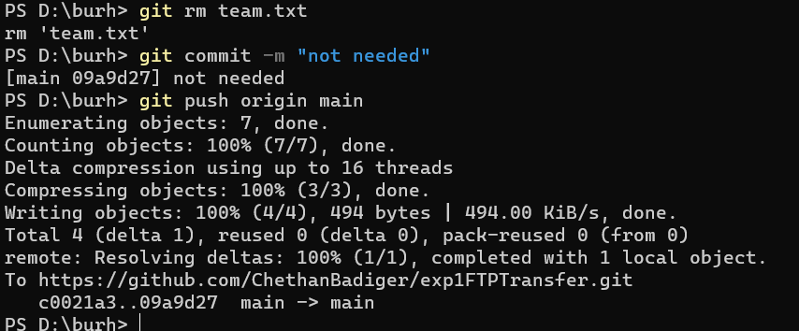

Check github for changes applied



1. to change port number on filezilla do these commands



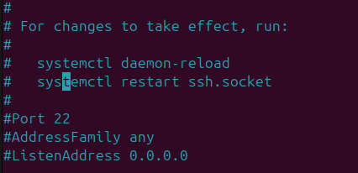

Change to port to this number (2222)

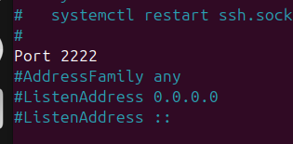

Then run these 2 commands



And restart the server



1. check if new port is being connected

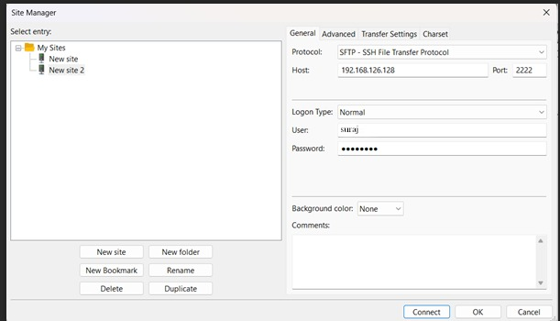

1. successfully connected on port 2222
2. 